Site Closure SOP

Dear Sites
Here is a summary of site closure activities and the corresponding dates. A checklist is also provided at the end of the document to aid the process. We do not require completed copies of the checklist.
(Please note these are final dates and these activities can be completed prior to the final date)
- The final date for patient recruitment in the FIDO study is the 31/08/2023 (No recruitment after this date will be accepted).

- The final date for patient data to be uploaded to RedCAP is the 31/10/2023
By this date, all patients should have either been consented or at least pack 1 of discharge prior to consent letter 1 sent out if appropriate. There will be an 8 week wash out period to enable all consent to be obtained. All FIDO samples without consent after the 8 week period should be discarded/destroyed.
All sites should ensure that all eligible (meeting the inclusion criteria) patients are uploaded to the REDCap database. This forms part of our screening process and helps to establish a baseline for potential patients and those recruited. Please watch the FIDO Café videos on how to upload data for screened patients.

Videos can be found here: https://www.fidostudy.co.uk/all-site-meetings
Password: QUB0507
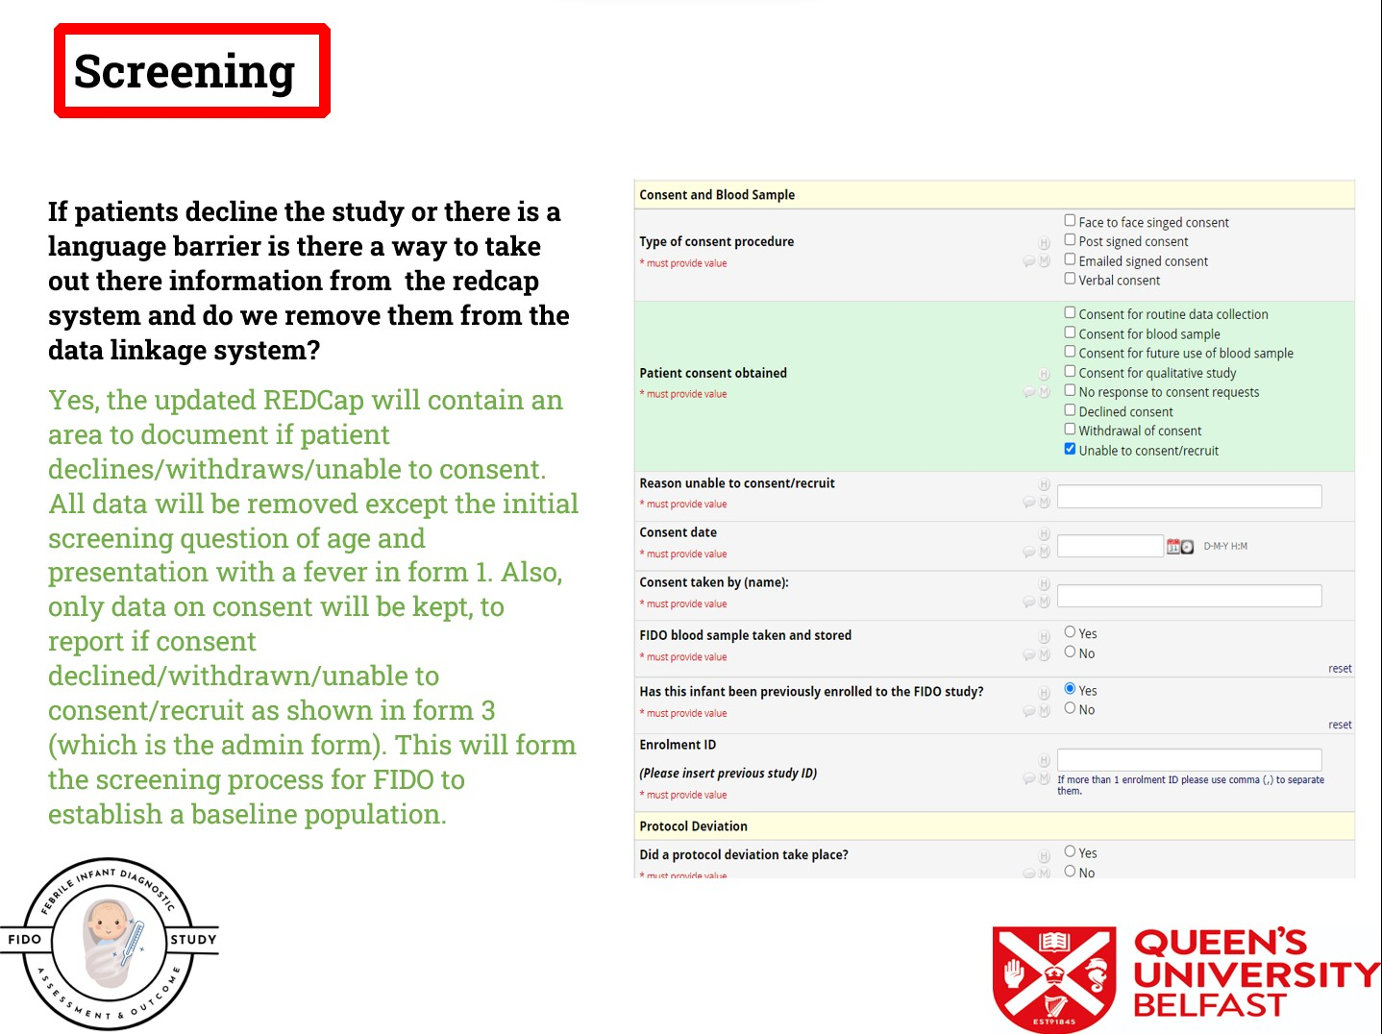

- Each Site Control for REDCap should run the data quality checks (further information can be found in the May and June FIDO café videos), please focus on the selected areas in the image below and sites should resolve all data queries by 30/11/2023
Videos can be found here: https://www.fidostudy.co.uk/all-site-meetings
Password: QUB0507
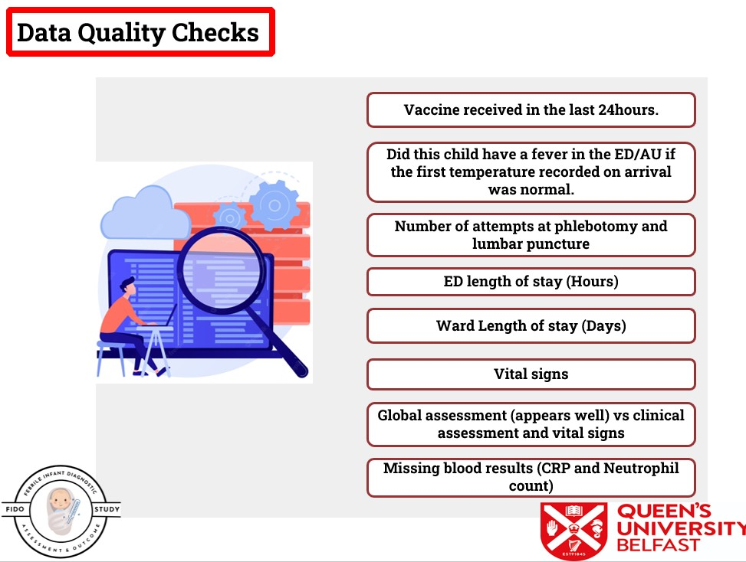

- 30/11/2023 is the final date for uploading CPMS accruals. Sites should ensure that all recruitment activities are accurately uploaded by this date to enable the NIHR to sign off. All sites will be sent to the REDCap link at the end of the data queries to complete a FIDO Closure Form. This form is important for publication purposes and site demographic information.

- We will contact the sites individually to arrange a date for sample shipment and confirm the shipment details. Once samples are received, confirmation will take place in the QUB regarding the final numbers and sample volume. The site can then send an invoice to the QUB as per the OID.

- The final study close out will be 14/12/2023. Sites will be issued with an end-of-study declaration and advised to locally archive their ISF for a minimum of five years (as per the QUB policy), which can be stored electronically or according to local policy.
Thank you for all your hard work on the FIDO study…

FIDO Study Closure Checklist – For site use only, we do not require completed copies.
No | Item | Yes | No | N/A
1 | All data quality checks completed
2 | All study data uploaded to REDCap
3 | All consent procedures completed
4 | Recruitment information completed on CPMS
5 | All Protocol deviation resolved with Study team
6 | Associate PI candidate signed off
7 | FIDO samples transferred to Queens University Belfast
8 | Invoice sent to FIDO study team for FIDO samples
9 | Confirm destruction of all unconsented FIDO samples
10 | ISF archived electronically or according to local policy
11 | Completed FIDO site exit survey on REDCap

